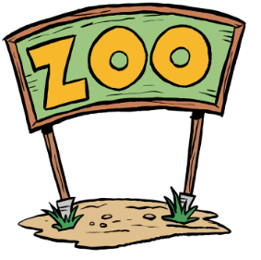
Our Zoo animal is a ____________________________________.
Copy and paste a picture of your zoo animal on this page.
the page. Then label your animal’s features.

Feature: ______________________
How does it help your animal in its habitat?
Feature: ______________________
How does it help your animal in its habitat?

Zoo Animal

Feature: ______________________
How does it help your animal in its habitat?
Feature: ______________________
How does it help your animal in its habitat?
Habitat

